**DIY setup with larger surface area : acoustic levitator**

* We can use ultrasonic transducer to provide sound pressure because it is in inaudible range with optimized pressure .it provides a standing waves when located at the correct distance
* Use acoustic waves to hold in mid-air samples such as water, ants or tiny electric components.
* We can design a simple mechanism for acoustically levitating small low density materials
* Transducer is placed at the base of the system vibrating rapidly. This vibration released sound pressure waves of a certain wavelength related to the frequency of vibration.

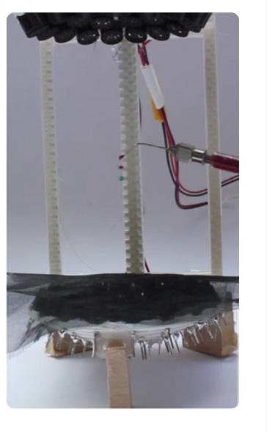

**INDIVIDUAL COMPONENTS**

* 72x 10mm 40kHz transducers.
* 1x 3D-printed TinyLev support
* 1x Arduino Nano
* 1x L298N Dual Motor Drive Board
* 1x 130x90mm sheet (wood or acrylic) for the base of the driver board
* Power switch
* DC adoptor variable between 7v and 12v
* DC female connector
* Jumper wires
* 12AWG black and red wire
* 24AWG exposed wire (
* Some Expanded Polystyrene beads to levitate (between 1mm and 3mm diameter)
* An acoustically transparent material: A metallic grid, very thin fabric or teabag paper.

**IMPORTANT TO0LS**

3D printer

Soldering Iron, Tin and Flux.

Hot-glue gun

Multimeter

Cable Peeler

Screwdriver and Pliers.

Drill

Oscilloscope with two probes

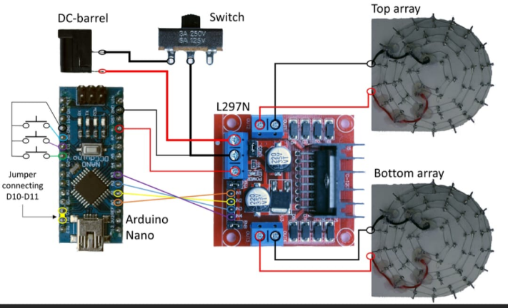

**FLOW CHART FOR THE PROCESS**

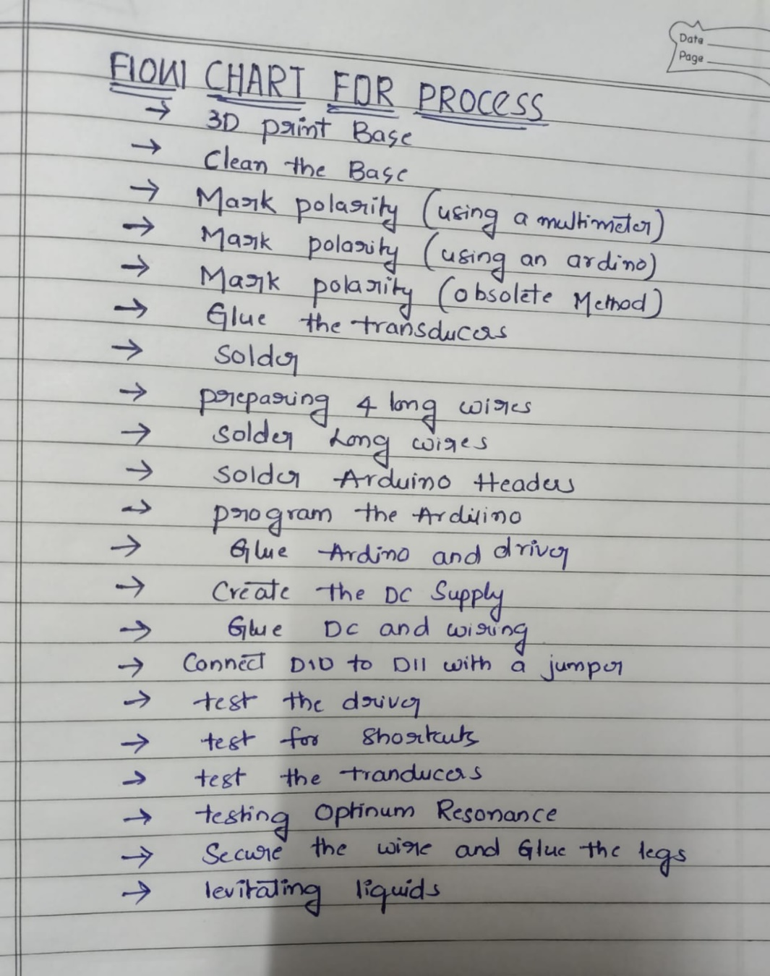

**PROCESS**

1. **3D PRINT BASE**

3D print the base for the levitator. We should use a 0.4mm nozzle and brim but no support.

1. **CLEAN THE BASE**

We should use a file to clean the edges around the levitator and we should clean the sockets

1. **MARKING POLARITIES (using multimeter)**

Using copper tape and multimeter we should mark the polarities

1. **MARK POLARITY USING ARDUINO**

The easiest way to mark the polarity is to use the Arduino itself. This method does not require an oscilloscope or to poke the transducers inside.

1. **MARKING POLARITY ABSOLUTE METHOD**

The transducers have polarity and it is important to glue them in the base oriented with the same polarity.

1. **GLUE THE TRANSDUCERS**

Apply a little bit of hot glue on the side of the socket.

push the transducer in and we should apply some pressure with our fingers to make it lay as flat as possible in the socket

1. **WIRE THE TRANSDUCERS**
2. We should wrap the exposed wire in six concentric rings around the legs of the transducers.

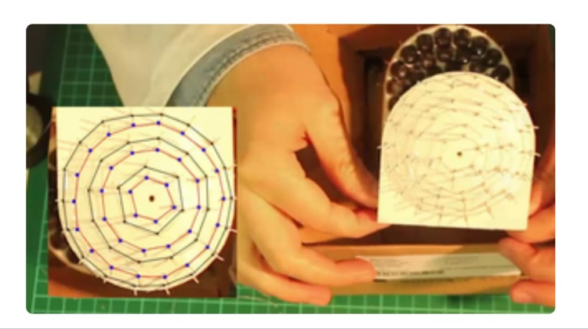

1. **SOLDER**

Solder the pins to the wires

10.**PREPARE 4 LONG WIRES**

Now, we need to make the wires that connect the transducers to the driver board.